Dollhouse Automation System
The Dollhouse Automation System is a collection of small, cheap microcontrollers in a simple network, allowing sensors (push buttons, motion detectors, light sensors etc) in one part of the house to control actions (lights, motors, sounds, etc) in another part of the house.
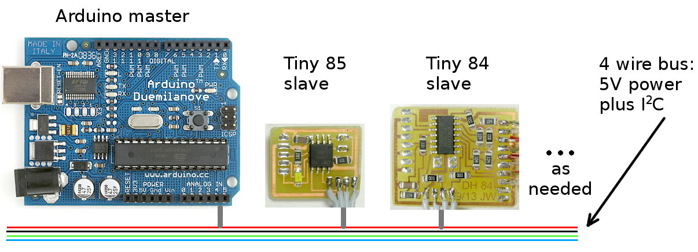

Hardware
The microcontrollers are all part of the same family as the popular Arduino. The slave I/O nodes are based on the AT Tiny 85 with three I/O pins or the Tiny 84 with nine, while an Arduino serves at the master.

Software
Using processors in the same family allows all development to be done in the comfortable Arduino environment. Code for the slaves can (usually) be ported easily to the Tiny processor and burned into its flash memory. Code in the slaves is simple and rarely changes.
The main code in the master consists of a set of “rules”
defining the behavior. A typical rule might be
For gory details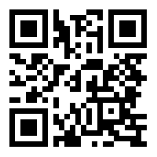
http://tinyurl.com/nl56lgs
If “Doorbell” button is pressed
trigger “Door Open” action
trigger sound “Creaky Door”
turn “Ghost LED” ON
Other code abstracts hardware details like
pin numbers and slave bus addresses into
easier-to-use names.

